**Parameter Definitions**

1. **Stance Duration - Left Foot:**

The stance phase is the weight phase supporting phase of each gait cycle. It begins with the contact of the heel of left foot and finishes with the set off of the tip of the same foot. It is therefore the time between the first and the last contact of two consecutive supports of the same foot.

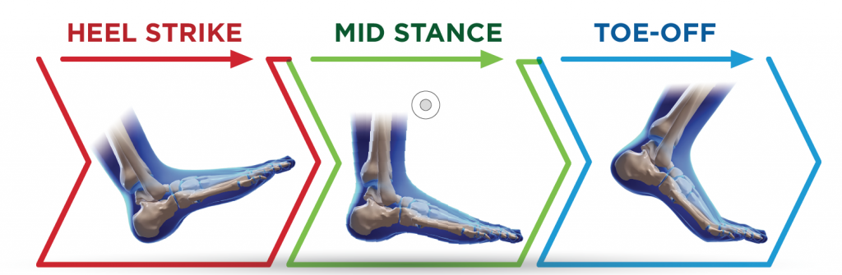

**Figure 1: Stance Duration**

1. **Absorption Phase:**

This is a combination of contact phase and foot flat phase.It begins with the contact of heel on the ground and finishes with the beginning of lifting of heel.

Contact Phase: The time between the first contact of the heel and the complete support of the foot.

Foot flat Phase: The time the foot completely touches the ground.

1. **Propulsive Phase:**

This is the phase where the time the foot completely touches the ground.

**Stride (100%)**

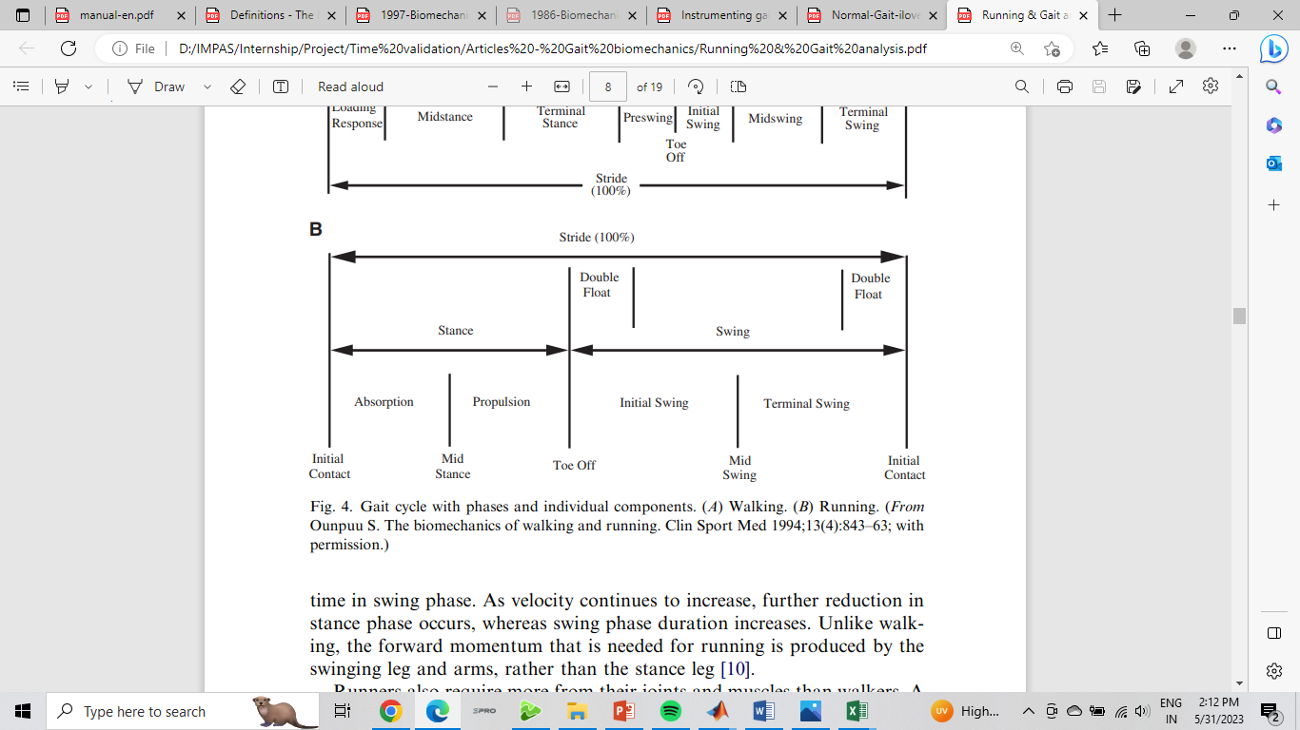

**Figure 2: Phases of a stride**

1. **Step Times between Final and Right Foot:**

The time between the first contact of right foot and the first contact of the final foot. It is the time taken to cover the step length between right and final step.

1. **Step Times between Right and Left Foot:**

The time between the first contact of left foot and the first contact of the right foot. It is the time taken to cover the step length between left and right step.

**Left Steps**

**Right Steps**

**Stride Length**

**Step Length**

Opta Gait Bars

**Figure 3: Step Length & Stride Length**

1. **Stride length of the Delivery Stride:**

The distance between the heel of the left foot and heel of the final foot (two subsequent footprints of the same foot) when both feet are placed flat to the surface (flat foot contact).

6.1 Delivery Stride**:**

The final stride of the left foot before the release of javelin.

1. **Stride Time of Delivery Stride:**

The time taken to complete the delivery stride before the release of javelin.

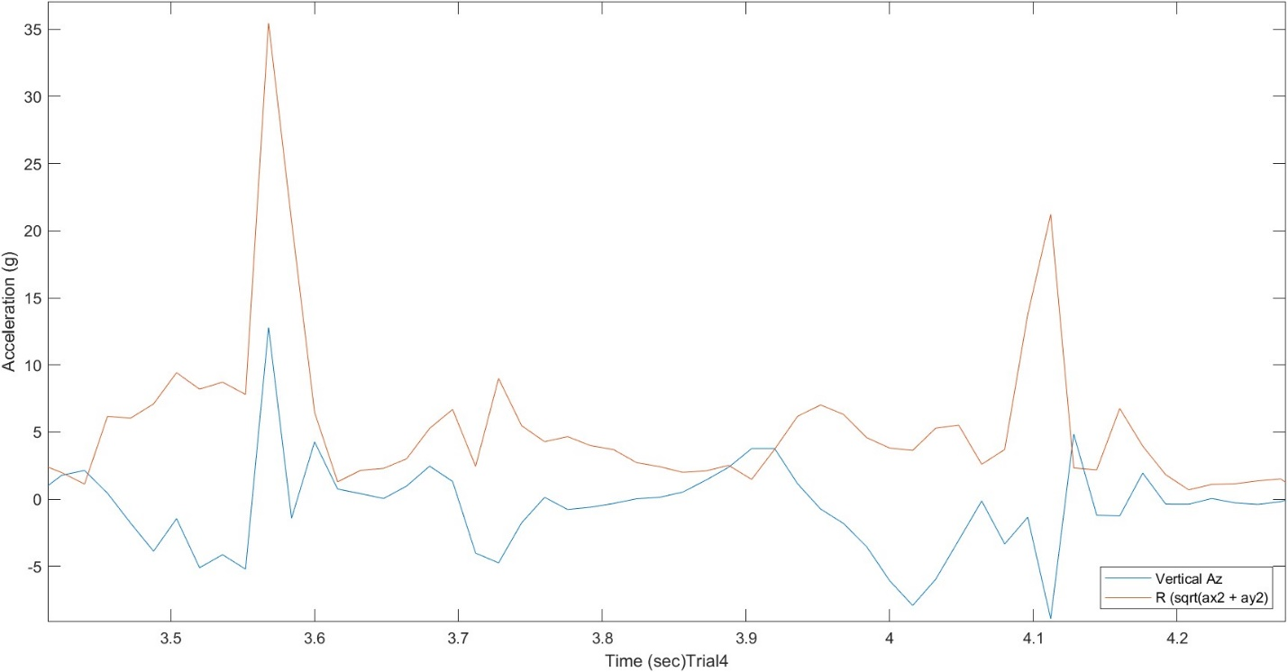

**Figure 4: Linear acceleration data of Left Foot**

Swing Phase

Stance Phase

Initial Contact of the left foot in stance phase

 Final Contact of the left foot in stance phase